* **Hu Moments** ( or rather Hu moment invariants ) are a set of 7 numbers calculated using central moments that are invariant to image transformations. The first 6 moments have been proved to be invariant to **translation**, **scale**, and **rotation**, and **reflection**. While the 7th moment’s sign changes for image reflection.
* This feature vector can be used to quantify and represent the shape of an object in an image

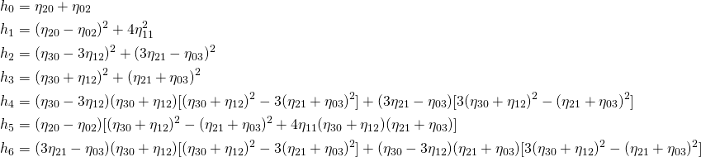

The first one, *I*1, is analogous to the [moment of inertia](https://en.wikipedia.org/wiki/Moment_of_inertia) around the image's centroid, where the pixels' intensities are analogous to physical density. The first six, *I*1 ... *I*6, are reflection symmetric, i.e. they are unchanged if the image is changed to a mirror image. The last one, *I*7, is reflection antisymmetric (changes sign under reflection), which enables it to distinguish mirror images of otherwise identical images.

Raw Moments

\begin{align*} M_{ij} = \sum_{x} \sum_{y} x^{i} y^{j} I(x,y) \end{align*}

**Centroid using Image Moments**

The centroid of a binary blob is simply its center of mass. The centroid (\bar{x},\bar{y}) is calculated using the following formula.

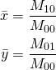

Central moments are very similar to the raw image moments we saw earlier, except that we subtract off the centroid from the x and y in the moment formula.

\begin{align*} \mu_{ij} = \sum_{x} \sum_{y} \left ( x - \bar{x} \right)^{i} \left ( y - \bar{y} \right )^{j} I(x,y) \end{align*}

**Normalized central moments**

\begin{align*} \eta_{ij} = \frac{\mu_{i,j}}{\mu_{00}^{(i+j)/2 + 1}} \end{align*}

**Haralick features**

Haralick texture features are calculated from a Gray Level Co-occurrence Matrix, (GLCM), a matrix that counts the co-occurrence of neighboring gray levels in the image. The GLCM is a square matrix that has the dimension of the number of gray levels *N* in the region of interest (ROI). Figure [4](https://www.nature.com/articles/s41598-017-04151-4#Fig4) gives an overview of how the GLCM is constructed and how the texture features are calculated.

[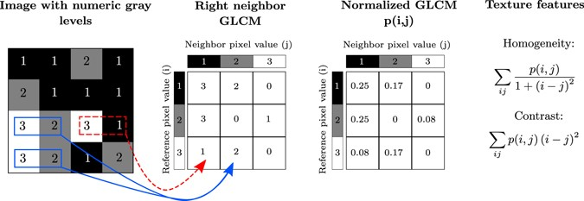](https://www.nature.com/articles/s41598-017-04151-4/figures/4)

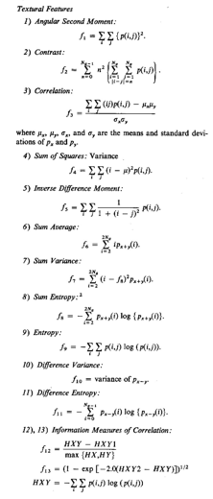

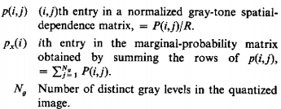

* Contrast (Moment 2 or standard deviation) is a measure of intensity or gray level variations between the reference pixel and its neighbor. Large contrast reflects large intensity differences in GLCM:



* Homogeneity measures how close the distribution of elements in the GLCM is to the diagonal of GLCM. As homogeneity increases, the contrast, typically, decreases:



* Entropy is the randomness or the degree of disorder present in the image. The value of entropy is the largest when all elements of the cooccurrence matrix are the same and small when elements are unequal:



* Energy is derived from the Angular Second Moment (ASM). The ASM measures the local uniformity of the gray levels. When pixels are very similar, the ASM value will be large.

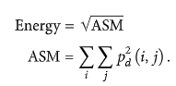

* Correlation feature shows the linear dependency of gray level values in the co-occurrence matrix:

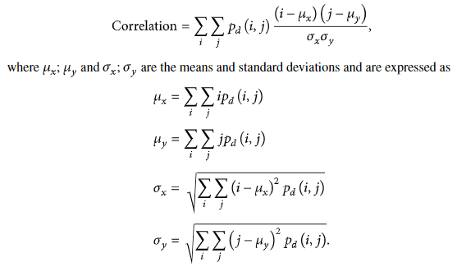

**SLIC ALGO (simple linear iterative clustering)**

**Distance measure**

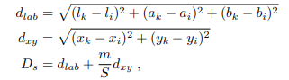



m-> measure(proximity consider for a superpixel)

**Eq-1**

**Gradient measure**

where I(x, y) is the lab vector corresponding to the pixel at position (x, y), and k.k is the L2 norm

**Algorithm**

1) Initialize cluster centers Ck = [lk, ak, bk, xk, yk]^T by sampling pixels at regular grid steps S.

2: Shift cluster centers in an n × n neighborhood, to the lowest gradient position.

3: repeat

4: for each cluster center Ck do

5) Assign the best matching pixels from a 2S × 2S square neighborhood around the cluster center according to the distance measure (Eq. 1).

6: end for

7: Compute new cluster centers and residual error E {L1 distance between previous centers and recomputed centers}

8: until E ≤ threshold

9: Enforce connectivity

**References**

Cong, Jinyu & Wei, Benzheng & Yin, Yilong & Xi, Xiaoming & Zheng, Yuanjie. (2014). Performance evaluation of simple linear iterative clustering algorithm on medical image processing. Bio-medical materials and engineering. 24. 3231-8. 10.3233/BME-141145.

<http://haralick.org/journals/TexturalFeatures.pdf>

https://en.wikipedia.org/wiki/Image\_moment